**Fujitsu Work Instructions**

Scanner Setup

**Fujitsu fi-7160**

**PaperStream Capture 1.0.12**

# PaperStream Capture

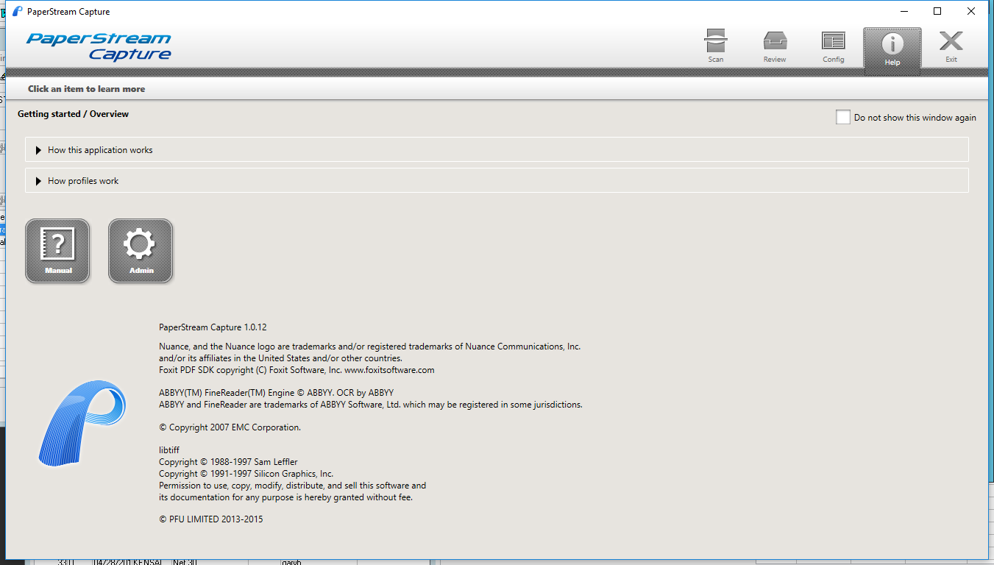

1. Select Config

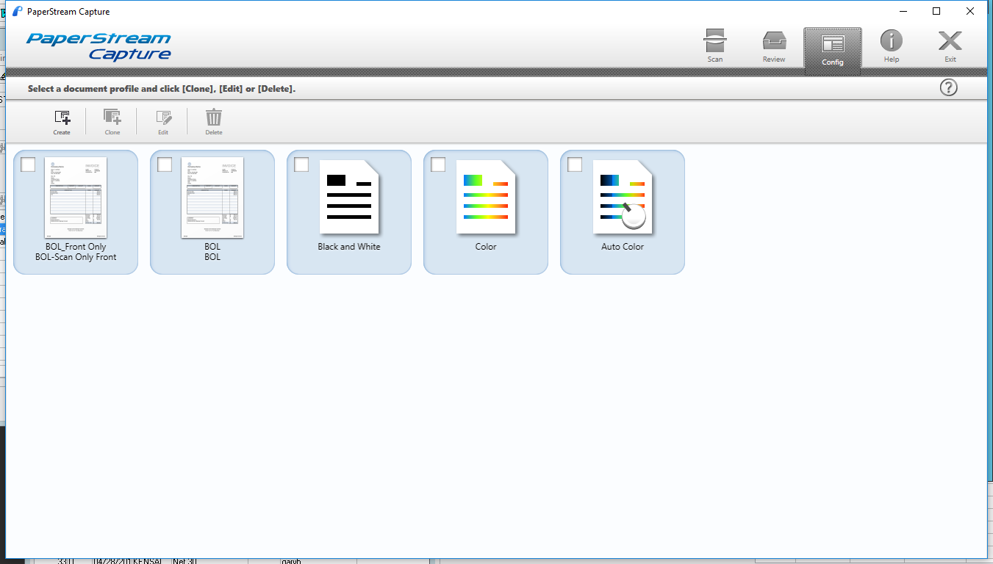

1. There are two setups
   1. BOL-Front Only (This is for freight docs that may have data that you do not want to scan such as terms and conditions)
   2. BOL (Scans both sides of documents)
2. Press the 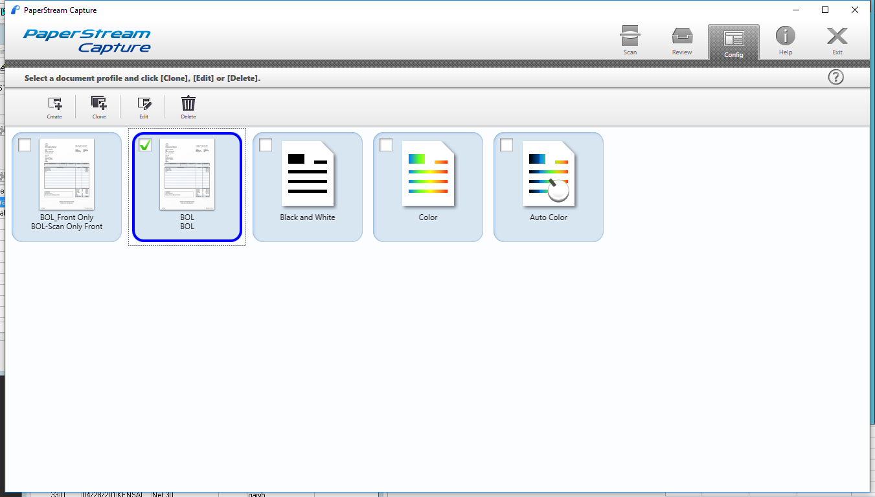 button to create a new profile.
   1. Or select from those shown and press the  to edit.
3. Name tab – Name the profile

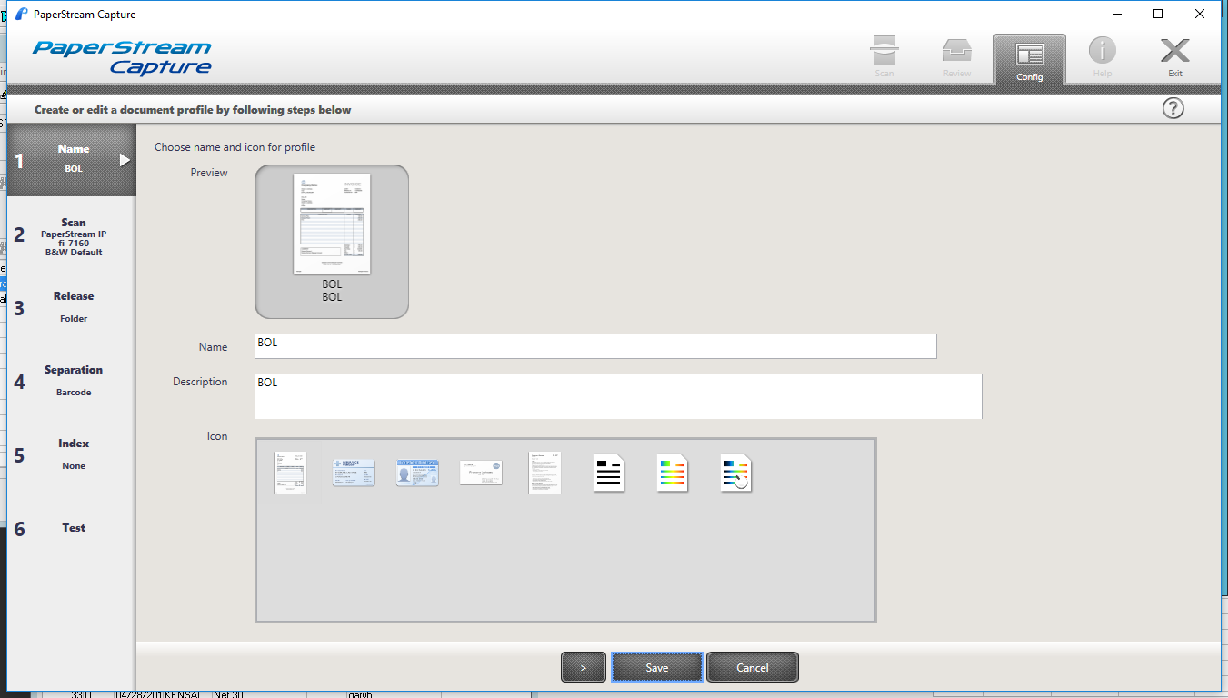

1. Scan tab

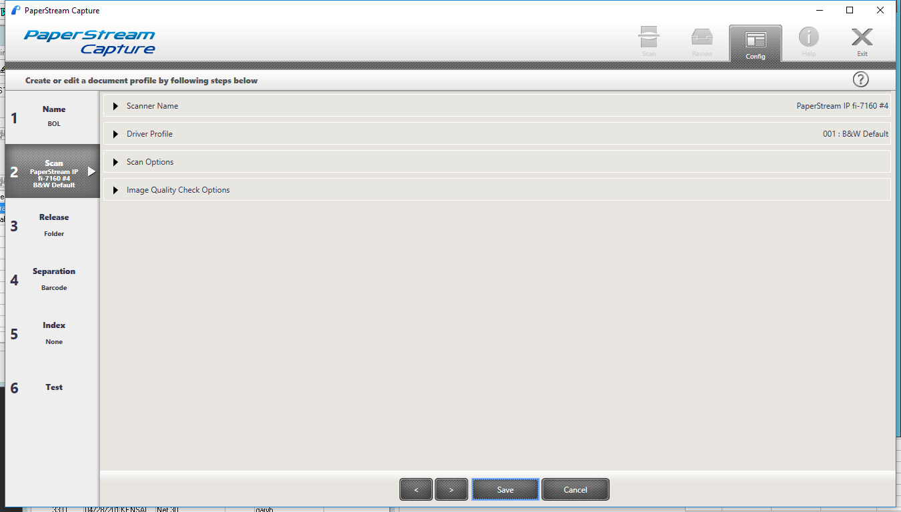

* 1. Scanner Name

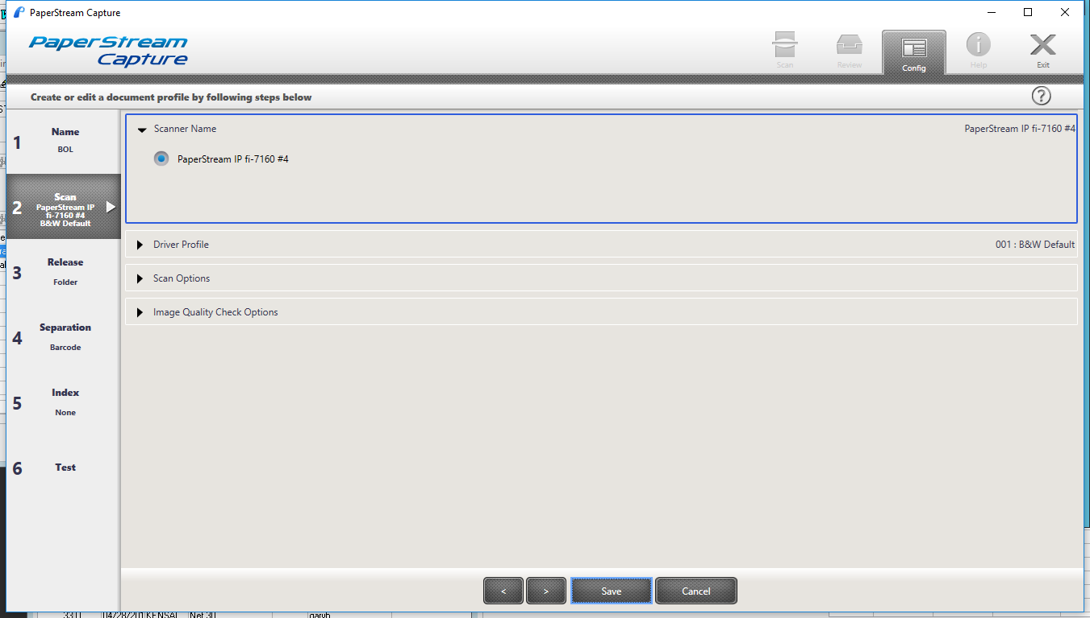

* 1. Driver Profile

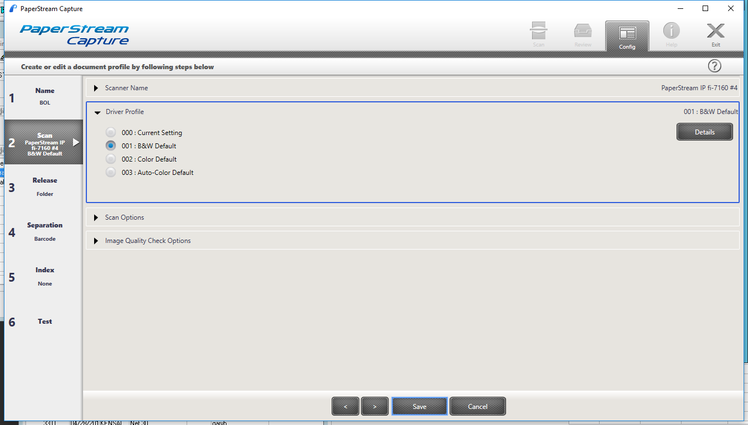

* 1. Scan Options

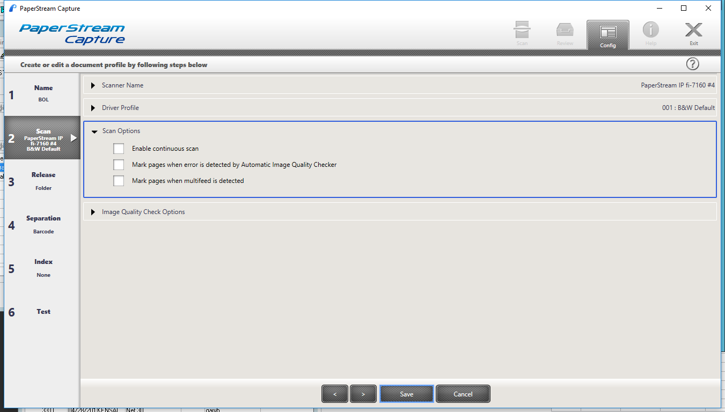

* 1. Image Quality Check Options

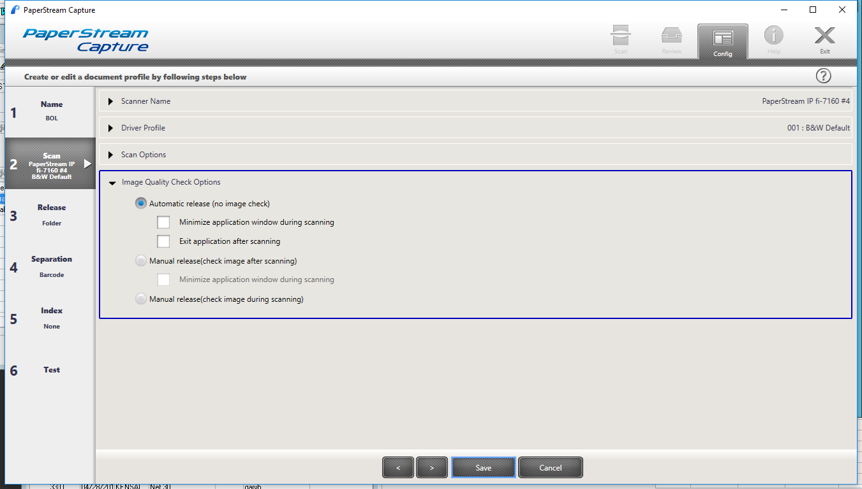

1. Release tab

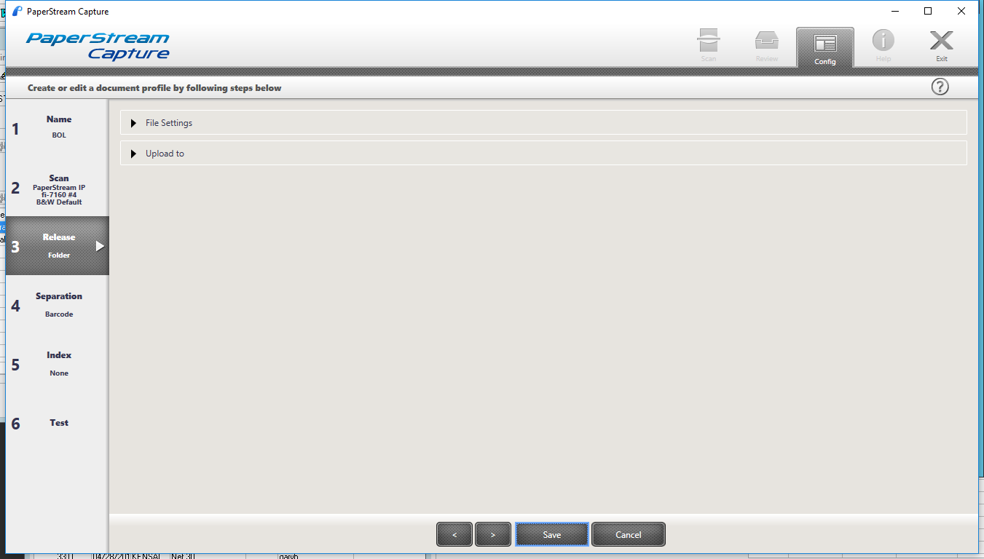

* 1. File Settings

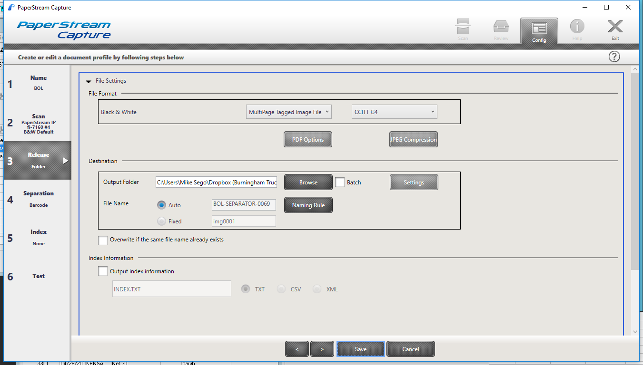

* + 1. File Name, press the 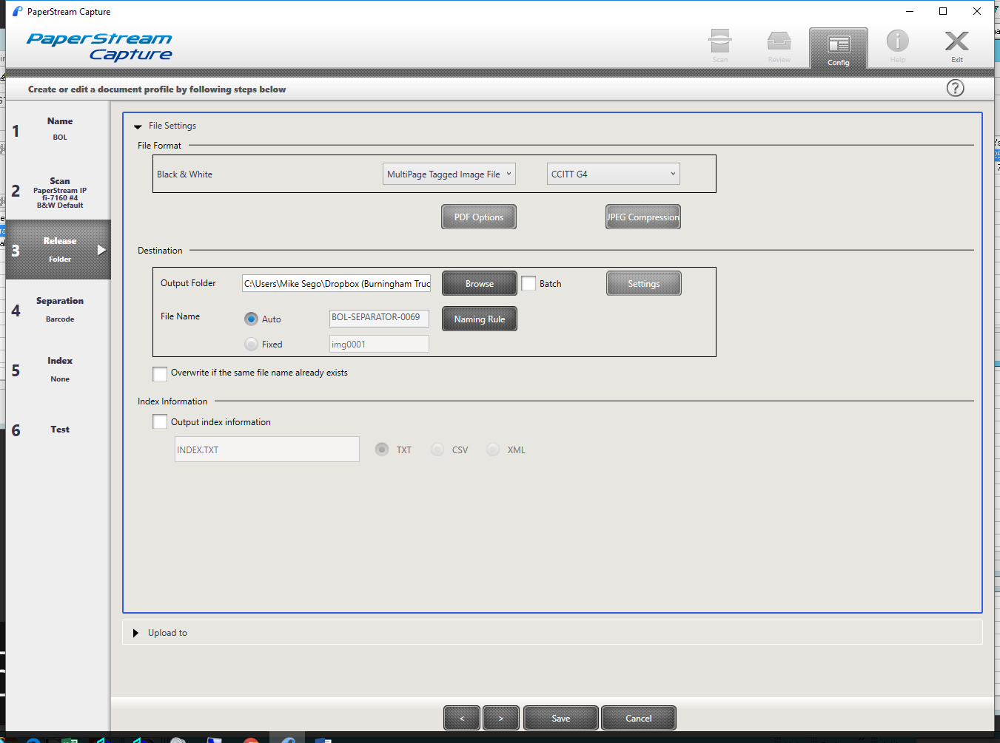 button to set up the naming rules for the file.

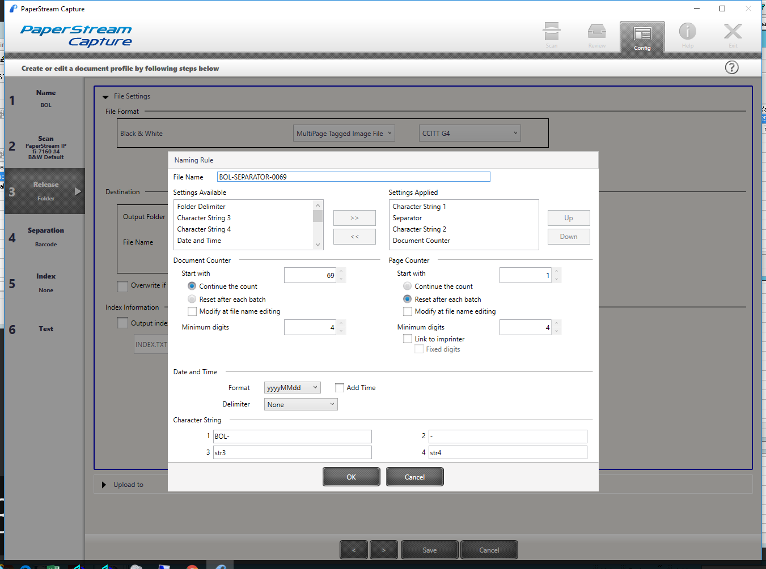

* 1. Upload To

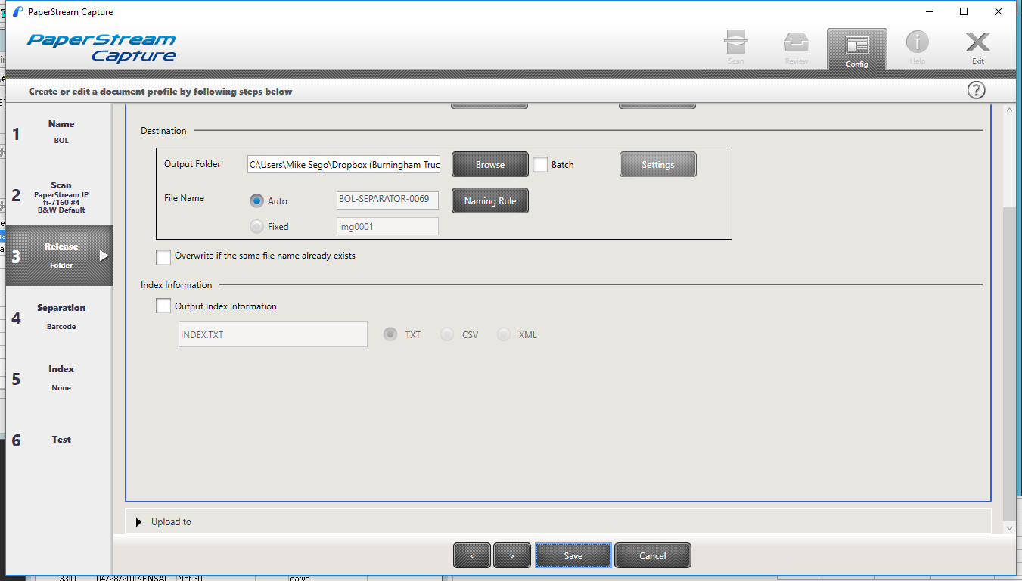

1. Separation tab – This where you identify the location of where to look for the barcode

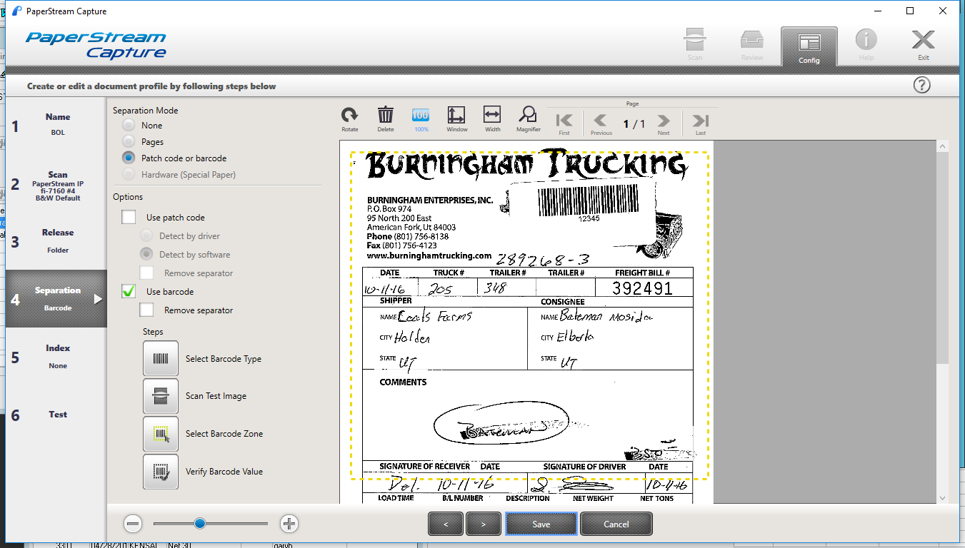

1. Index tab

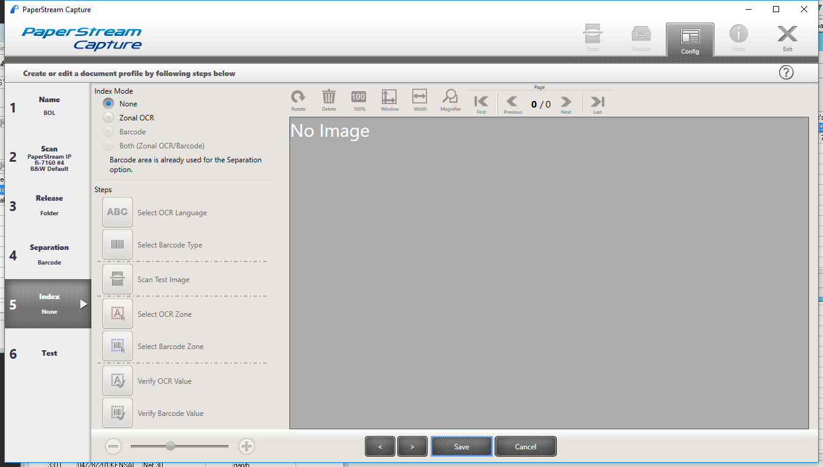

1. Test tab

